# Introduction

Engineering design ideation employs a variety of techniques, each focused on outputting a wide variety of ideas. For successful concept generation, the design team must have a developed understanding of the problem. In producing the ideas presented below, the design team considered that a physical version of the system already exists. The problem areas were identified, and key goals were recalled to generate a list of 100 improved design ideas. One ideation technique used was biomimicry. The biological characteristics of living organisms were analyzed to inspire a mechanical design concept containing similar features (Institute, n.d.). The solutions seen in nature have developed over centuries for optimized existence and survival and can be translated into manmade designs. The design team used biomimicry to generate ideas involving a honeycomb frame structure, an octopus-style pressing technique, and gecko-like gripping strategies, among others.

Another main ideation tactic used was a morphological chart, displayed in APPENDIX LETTER. The problem was broken down into the key functions and features of storage, movement, alignment, pressing, and ejection. Possible solutions were listed under each of these functions, and unique concepts were generated by following a combination of one item in each column. This allowed for a comprehensive exploration of possible solutions and creative combinations.

Crap shoot and forced analogy are other ideation techniques that were employed by the design team less extensively. Many ideas were inspired through a conversation with the project sponsor on the significant flaws present and alternative operation techniques.

# Three High Fidelity Concepts

Upon evaluation of the key goals and customer needs, along with the generated targets and metrics, the design team was able to select the three high fidelity concepts that had the best potential for success and satisfaction. The table below narrates the justification for selecting each design and specifies the attributes of the concept.

|  |  |  |
| --- | --- | --- |
| Concept  Number | Selection | Description |
| 77 | This design was selected for its ability to reasonably and successfully achieve the previously generated key goals and customer needs. The triangular-based support frame would include diagonal bars for support to counteract the current instability. The shock-absorbent surrounding of the linear actuator mount would work to reduce misalignment from vibrations. The user-controlled claw is an effective way to keep the user engaged while automating the entire production process. | Button pin maker with a triangular-based support frame and linear actuator mounted with shock-absorbent material that includes a user-controlled claw to pick up and dispense the final product in an engaging manner. |
| 3 | This design was selected for its ability to reasonably and successfully achieve the previously generated key goals and customer needs. The gravity fed storage system allows automation of dispensing raw materials without the requirement of excessive power. The alignment of the design will be guided with visual marks for the user to follow. The user-controlled claw is an effective way to keep the user engaged while automating the entire production process. | Button pin system that uses a gravity fed storage system to move raw materials, visual marks for alignment, linear actuator for press, and a user-controlled claw for moving the completed button. Generated using a morphological chart. |
| 85 | This design was selected for its ability to reasonably and successfully achieve the previously generated key goals and customer needs. The interface educates the user on the manufacturing process as the system operates. The user-controlled claw is an effective way to keep the user engaged while automating the entire production process. | Button pin maker with an interface to convey the current manufacturing step to the user and user-controlled claw to pick up the final product. |

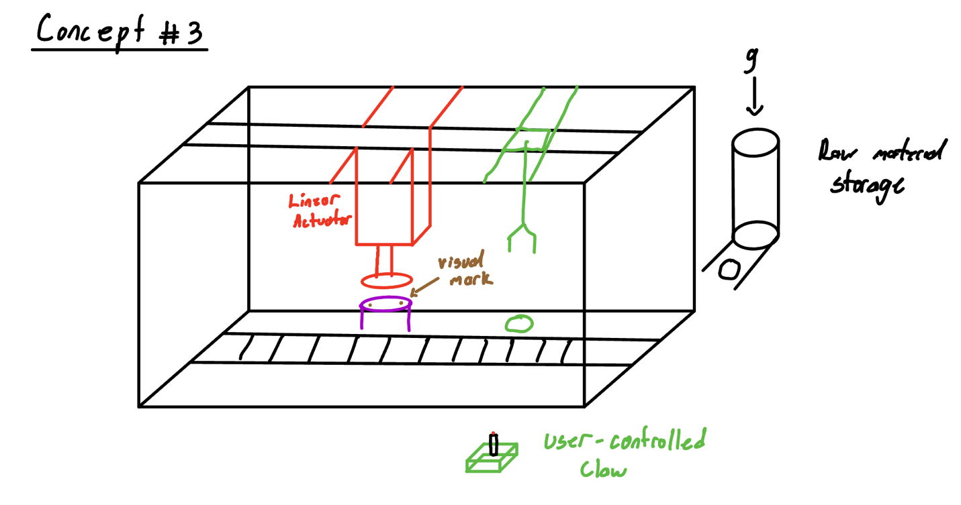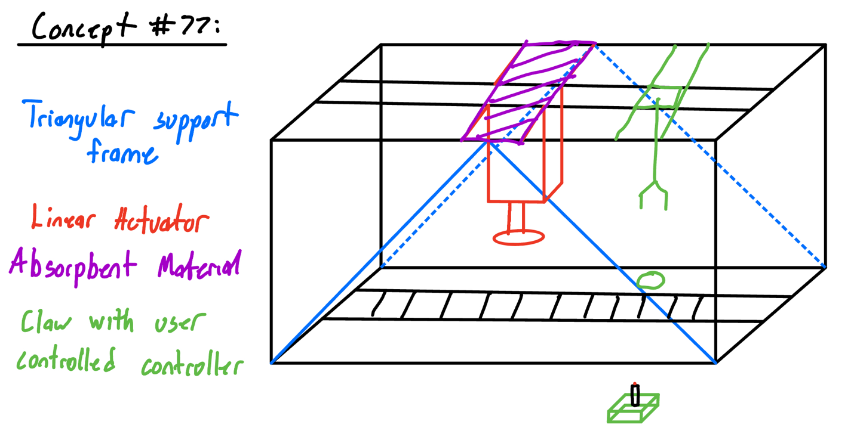

# Five Medium Fidelity Concepts

The five medium fidelity concepts were selected for their good potential to meet the key goals and customer needs. They were ranked lower than the high-fidelity concepts but were still agreed to hold great promise.

|  |  |  |
| --- | --- | --- |
| Concept  Number | Selection | Description |
| 48 | This design was selected for its potential to reasonably and successfully achieve the previously generated key goals and customer needs. The interface for customizing the button keeps the user engaged and ensures the design it sealed to the button top properly aligned. | Button pin maker that includes a touchscreen interface for users to select button color, graphic, and add text before printing their design. |
| 51 | This design was selected for its potential to reasonably and successfully achieve the previously generated key goals and customer needs. The puzzle characteristic builds engagement with the young audience and allows for easier storage. | Button pin maker that contains puzzle style metal pieces, to be easily broken down for storage |
| 78 | This design was selected for its potential to reasonably and successfully achieve the previously generated key goals and customer needs. The user-controlled claw is an effective way to keep the user engaged while automating the entire production process. The dual axis conveyor belt allows the manufacturing process to move beyond a simple, straight line. | Button pin maker with user-controlled claw and a dual axis conveyor belt. |
| 90 | This design was selected for its potential to reasonably and successfully achieve the previously generated key goals and customer needs. The heat shrinkable mylar ensures the design is properly sealed to the button top. The load sensor allows the linear actuator to perform real-time adjustment and enhance the safety of the system. | Button pin maker with heat shrinkable mylar and a load sensor beneath the frame to detect uneven pressure distribution during the actuator pressing process and adjust the actuator’s position in real-time |
| 95 | This design was selected for its potential to reasonably and successfully achieve the previously generated key goals and customer needs. The collapsible frame is something that was pointed out by the stakeholders, as the end goal is to have something that can be easily transported from location to location. The touchscreen will be effective in engaging the audience and being able to describe each step in the manufacturing process. The vacuum-based arm will be an improvement over the current design because it will allow for a more effective extraction of button pins. | Button pin maker that includes easily collapsible frame and touchscreen interface for status display and a vacuum based arm for extraction and dispensing |

# 100 Concepts

Might be appendix A

|  |  |
| --- | --- |
| Concept  Number | Description |
| 1 | A button maker system that uses an automated feeder storage system, that utilizes a conveyor to move raw materials, visual marks for alignment, Linear Actuator for pressing and a magnet to move the completed button. Generated using a morphological chart. |
| 2 | Button pin system that uses a gravity fed storage system that utilizes conveyors to move raw materials, visual marks for alignment, linear actuator for pressing, and a magnet to move the completed button. Generated using a morphological chart. |
| 3*** | Button pin system that uses a gravity fed storage system to move raw materials, visual marks for alignment, linear actuator for press, and a magnet for moving the completed button. Generated using a morphological chart. |
| 4 | button pin system that uses an automated feeder storage system with a robotic arm to move raw materials, visual marks for alignment, linear actuator for pressing and a spatula like tool for moving the completed button. Generated using a morphological chart. |
| 5 | Button pin system that uses a gravity fed storage system with a vacuum arm to move raw materials, uses pins for alignment, linear actuator for pressing, and a magnet to move the completed button. |
| 6 | Button pin system that uses an automated feeder storage system and a magnet to move raw materials, pins for alignment, a CAM system for pressing, and a magnet to move the completed button. Generated using a morphological chart. |
| 7 | Button pin system that uses an automated feeder storage system and a slide rail to move raw materials. Pins for alignment and a linear actuator for pressing, and a pneumatic ejector for moving the completed button. Generated using a morphological chart. |
| 8 | Button pin system that uses an automated feeder storage system and a gantry to move raw materials, visual marks for alignment, a lead screw for pressing, and a vacuum to move the completed button. Generated using a morphological chart. |
| 9 | Button pin system that uses a gravity fed storage system and a robotic arm to move raw materials, visual aids for alignment and a linear actuator for pressing. A slide will move the completed button. Generated using a morphological chart. |
| 10 | Button pin system that uses a gravity fed storage system and uses a turntable to move raw materials, pins for alignment and a linear actuator for pressing. A vacuum arm is used to move the completed button. Generated using a morphological chart. |
| 11 | Button pin system that uses a gravity fed storage system and uses a conveyor to move raw materials, visual marks for alignment, a lead screw for pressing. A slide will be used to move the completed button. Generated using a morphological chart. |
| 12 | Button pin system that uses an automated feeder storage system and uses a turntable to move raw material, pins for alignment, a CAM system for pressing and a magnet to move the completed button. Generated using a morphological chart. |
| 13 | Button pin system that uses a gravity fed storage system and use a slide rail to move raw materials, visual marks for alignment, a lead screw for pressing, and a vacuum arm to move the completed button. Generated using a morphological chart. |
| 14 | Button pin system that uses automated feeder storage system and uses a robotic arm to move raw materials, pins for alignment, a linear actuator for pressing and a slide to move the completed button. Generated using a morphological chart. |
| 15 | Button pin system that uses a gravity fed storage system and uses a gantry to move raw materials, visual marks for alignment, a lead screw for pressing and a spatula like tool for moving the completed button. Generated using a morphological chart. |
| 16 | Button pin system that uses an automated feeder storage system and uses a vacuum to move raw materials, pins for alignment, a CAM system for pressing and a pneumatic ejector to move the completed button. Generated using a morphological chart. |
| 17 | Button pin system that uses a gravity fed system and uses a conveyor to move raw materials, visual marks for alignment, a linear actuator for pressing, and a spatula like tool for moving the completed button. Generated using a morphological chart. |
| 18 | Button pin system that uses an automated feeder storage system that uses magnets to move the raw materials, pins for alignment, a linear actuator for pressing and a vacuum arm to move the completed button. Generated using a morphological chart. |
| 19 | Button pin system that uses a gravity fed system that uses a turntable to move raw materials, visual marks for alignment, a CAM system for pressing and a magnet for moving the completed button. Generated using a morphological chart. |
| 20 | Button pin system that uses an automated feeder storage system and uses a gantry to move raw materials, pins for alignment, a lead screw for pressing and a pneumatic ejector for moving the completed button. Generated using a morphological chart. |
| 21 | Button pin system that uses a gravity fed storage system and uses a magnet to move the raw materials, visual marks for alignment, a lead screw for pressing and a slide to move the completed button. Generated using a morphological chart. |
| 22 | Button pin system that uses an automated feeder storage system and uses a slide rail to move raw materials, pins for alignment, a linear actuator for pressing, and a vacuum arm to move the completed button. Generated using a morphological chart. |
| 23 | Button pin system that uses a gravity fed storage system and uses a robotic arm to move the raw materials, visual marks for alignment, a CAM system for pressing, and a magnet to move the completed button. Generated using a morphological chart. |
| 24 | Button pin system that uses an automated feeder storage system and uses a conveyor to move raw materials, pins for alignment, a CAM system for pressing, and a spatula like tool for moving the completed button. Generated using a morphological chart. |
| 25 | Button pin system that uses a gravity fed storage system and uses a vacuum arm to move raw materials, visual marks for alignment, a lead screw for pressing, and a pneumatic ejector for moving the completed button. Generated using a morphological chart. |
| 26 | Button pin maker encased in plexiglass with interlocking safety switches to automatically halt operation if the enclosure is opened. |
| 27 | Button pin maker with diagonal braces added to the aluminum frame (mimics bird bone structure). |
| 28 | Button pin maker that utilizes electromagnets in the die molds that can be activated to hold the button components in place before pressing to ensure orientation. |
| 29 | Button pin maker with an actuator that includes an initial pressing stage of a light press to align the components and a delayed strong press to secure the button (like how an octopus gradually grips using its tentacle). |
| 30 | Button pin maker with linear actuator mounted with shock-absorbing materials or springs to reduce vibrations and increase stability when pressing. |
| 31 | Button pin maker that uses RFID technology to track the progress of each button. |
| 32 | Button pin maker with a reactive conveyor speed that follows the progress of the button and dynamically adjusts speed to improve efficiency. |
| 33 | Button pin maker that automatically extends a safety shield when the linear actuator is pressing for safety and retracts it upon completion for visibility. |
| 34 | Button pin maker with a robotic arm that uses a vacuum gripper to pick up the raw materials and place them in the die molds. |
| 35 | Button pin maker with a linear actuator on a swivel mount to allow precise alignment with the die mold. |
| 36 | Button pin maker with a honeycomb-patterned aluminum frame for better load distribution (biomimicry). |
| 37 | Button pin maker with an ejection mechanism that pushes the completed button onto a conveyor for delivery to the user. |
| 38 | Button pin maker with a touchscreen interface to convey the current manufacturing step to the user. |
| 39 | Button pin maker that uses laser pointers and sensors to guide where components should be placed in the die mold. |
| 40 | Button pin maker with a dual-axis conveyor system for side-to-side component movement, as well as forward and backward. |
| 41 | Button pin maker with pneumatic actuators in the die molds to allow for gentle insertion of the raw materials before pressing. |
| 42 | Button pin maker with grip surfaces on the die molds to securely hold components (like gecko feet). |
| 43 | Button pin maker with heating elements to warm button components slightly before pressing to ensure materials are malleable and form strong bonds. |
| 44 | Button pin maker with sensors to detect the pressing force of the linear actuator and adjust it based on the materials in use. |
| 45 | Button pin maker with self-lubricating materials for the linear actuator rails to reduce friction and enhance longevity. |
| 46 | Button pin maker with LED lights in various locations to indicate the status of different processes (pressing, idle, error, etc.). |
| 47 | Button pin maker with sound-absorbing materials lining the enclosure to reduce noise during operation. |
| 48* | Button pin maker that includes a touchscreen interface for users to select button color, graphic, and add text before printing their design. |
| 49 | Button pin maker with an automatic vision alignment system that uses cameras and image recognition software to detect the orientation of personalized graphics. |
| 50 | Button pin maker with a load sensor beneath the frame to detect uneven pressure distribution during the pressing process and adjust the actuator’s position in real-time (like a chameleon’s foot adapting to different surfaces). |
| 51* | Button pin maker that contains puzzle style metal pieces, to be easily broken down for storage |
| 52 | Button pin maker contains a stronger localized magnet that allows for easier distribution to the output zone |
| 53 | Button pin maker that integrates laser safety curtains into the system to immediately stop the operation if there is an interference. |
| 54 | Add a transparent cover made of some material to the button pin maker to block access to the inside of the system but still allowing for viewing. |
| 55 | Button pin maker with an external rechargeable battery for times where it may not be optimal to be plugged in. |
| 56 | Button pin maker with vibration isolating pads attached to the bottom of the setup to increase stability in the system. |
| 57 | Install new die casts to the button pin maker with a mechanism to be able to flip the product out through the back of the system. |
| 58 | Inspired by a spider’s web, install safety nets to the button pin maker that can be added to the side of the system to prevent tiny fingers and extremities from getting to the system as it works. |
| 59 | Inspired by a woodpecker’s skull, add shock absorption materials to the button pin maker to reduce the actuator stress. |
| 60 | Button pin maker with audible warning sounds that play when the maker is in failure. |
| 61 | Button pin maker with large video display that will display the step of the process the maker is on and will show what the maker is currently working on. |
| 62 | Button pin maker with a collapsible frame design to allow for easier transportation. |
| 63 | Create a button pin maker with 2 smaller linear actuators that will work on synchronized pressing operations for the button pin to save time. |
| 64 | Create a button pin maker with a voice control aspect to it to assist K-12 teachers run through the process of creating the button pin maker and to fill in gaps that they might not understand. |
| 65 | Create a button pin maker that has a different activation mode when being operated by a child to make it safer for one to operate. |
| 66 | Create a button pin maker that has a magnetic picker inspired by a bird-beak. |
| 67 | Create a button pin maker that will initiate a safety cushion inspired by a pufferfish that will automatically inflate in the case of an error. |
| 68 | Create a button pin maker that will fully operate off 2 buttons that use a start and emergency stop. |
| 69 | Create a button pin maker that will have an automated switch that controls our linear actuator tab that will allow for less user contact with the machine. |
| 70 | Create a button pin maker that will have a separate display that will show how many buttons have been produced in real-time. |
| 71 | Add in an artificial intelligence module to the button pin maker that can detect faulty buttons from good buttons and immediately throw them away. |
| 72 | Add pneumatic tubes to the side of the button pin maker to store the materials that make the button pin. |
| 73 | Create a way for the button pin maker to be able to display diagnostic reports after each run. |
| 74 | Add LED lights to the button pin maker to display and differentiate each step of the manufacturing process |
| 75 | Create a button pin maker with segmented actuators that will ensure more precise button pressing. |
| 76 | Button pin maker with a voice recognition system that enables hands-free operation, allowing users to control the button-making process through voice commands. |
| 77*** | Button pin maker with a triangular-based support frame and linear actuator mounted with shock-absorbent material that includes a user-controlled claw to pick up and dispense the final product in an engaging manner. |
| 78* | Button pin maker with user-controlled claw and a dual axis conveyor belt |
| 79 | Button pin maker that allows users to adjust the pressing speed to prioritize precision for delicate materials or increase speed for high-volume production. |
| 80 | Button pin maker that detects when materials are running low and alerts the user or even connects to an online ordering system for automatic replenishment. |
| 81 | A portable version of the button pin maker that charges itself via a hand crank or other kinetic energy source, suitable for events or areas without access to electricity. |
| 82 | Button pin maker that instead of pressing the button's components together, uses a magnetic assembly process that quickly snaps the parts into place without physical pressure. |
| 83 | Button pin maker with a time capsule feature that allows users to insert a small note or memento inside the button casing, sealed with a clear cover, to be opened at a future date. |
| 84 | Button pin maker that allows the use to orient the paper in which ever direction they’d like. |
| 85*** | Button pin maker with an interface to convey the current manufacturing step to the user and user-controlled claw to pick up the final product. |
| 86 | Button pin maker that integrates small magnets in the molds and materials to automatically align the button components before pressing. This ensures precise placement without the need for manual adjustment, improving the consistency and speed of production. |
| 87 | Button pin maker that incorporates a conveyor belt or automated feeder to load button materials into the press area. This reduces the need for manual loading and speeds up the production process by ensuring a continuous supply of materials. |
| 88 | Button pin maker that integrates a heat element in the press to slightly warm the materials during pressing, making the button components bond more securely. This is especially useful for plastic or composite materials where heat can enhance the adhesion between layers. |
| 89 | Button pin maker that adds a small air compressor that automatically ejects completed buttons from the mold area after pressing. This feature speeds up production by clearing the press for the next cycle without manual intervention. |
| 90* | Button pin maker with heat shrinkable mylar and a load sensor beneath the frame to detect uneven pressure distribution during the actuator pressing process and adjust the actuator’s position in real-time |
| 91 | Button pin maker that incorporates a sensor within the press that measures the pressure applied and checks for any inconsistencies during each cycle. If the machine detects an anomaly, it pauses the process and alerts the operator to inspect the button. |
| 92 | Button pin maker that integrates a digital screen that shows the current press settings, such as pressure level and cycle time, as well as a counter for the number of buttons made. This helps monitor the production process and manage output. |
| 93 | Button pin maker presses multiple buttons simultaneously in one cycle. This significantly boosts production efficiency for batch orders by allowing two or more buttons to be produced at once. |
| 94 | Button pin maker that uses a magnetic pad at the base of the press to hold metal components securely in place before pressing. This helps keep the button parts aligned and prevents them from shifting during the press-down action. |
| 95* | Button pin maker that includes easily collapsible frame and touchscreen interface for status display and a vacuum-based arm for extraction and dispensing |
| 96 | Button pin maker that incorporates a vibration function that activates during pressing to help the materials settle more evenly. This can enhance the bonding of components by eliminating small air gaps and achieving a tighter fit. |
| 97 | Button pin maker includes a spring-loaded mechanism that gently pushes the completed button out of the die after pressing. This reduces the need for manual removal and speeds up the cycle time. |
| 98 | Button pin maker that adds a transparent safety cover that encloses the pressing area. This prevents accidental contact with the press while allowing operators to monitor the process visually. |
| 99 | Button pin maker that includes a dust cover that automatically moves over the press area when not in use, keeping the paper and plastic clean and free from dust. |
| 100 | Button pin maker that is able to be charged via solar energy. |

# Appendix B ranking order chart

# Appendix B

|  |  |  |  |  |
| --- | --- | --- | --- | --- |
| **Morphological Chart** | | | | |
| **Storage** | **Movement** | **Alignment** | **Pressing** | **Ejection** |
| Gravity fed | Conveyor | Pins | Electromechanical actuator | Pneumatic ejector |
| Automated feeding | Robotic arm | Visual marks | Cam System | Vacuum |
|  | Gantry Crane |  | Screw mechanism | Slide |
|  | Vacuum |  |  | Magnet |
|  | Magnets |  |  | flipper |
|  | Slide rails |  |  |  |
|  | turntables |  |  |  |

# Appendix C

|  |  |  |  |  |  |
| --- | --- | --- | --- | --- | --- |
| Ranking Chart | | | | | |
| Concept | Carlos | Tristian | Leah | Xavier | Total |
| 85* | 7 | 8 | 8 | 7 | 30 |
| 51 | 5 | 3 | 4 | 8 | 20 |
| 95 | 4 | 1 | 2 | 3 | 10 |
| 3* | 6 | 7 | 6 | 6 | 25 |
| 90 | 2 | 4 | 5 | 2 | 13 |
| 78 | 1 | 5 | 1 | 1 | 9 |
| 48 | 3 | 2 | 2 | 4 | 11 |
| 77* | 8 | 6 | 7 | 5 | 26 |

# References

Institute, T. B. (n.d.). *Innovation Inspired by Nature*. Retrieved from asknature: https://asknature.org/